Example 1:  A simple example showing how to create a datacenter with one host and run one cloudlet on it. | Starting CloudSimExample1...  Initialising...  Starting CloudSim version 3.0  Datacenter_0_cse is starting...  Broker is starting...  Entities started.  0.0: Broker: Cloud Resource List received with 1 resource(s)  0.0: Broker: Trying to Create VM #0 in Datacenter_0_cse  0.0: Broker: Trying to Create VM #0 in Datacenter_0_cse  0.1: Broker: VM #0 has been created in Datacenter #2, Host #0  0.1: Broker: Creation of VM #0 failed in Datacenter #2  0.1: Broker: Sending cloudlet 0 to VM #0  400.1: Broker: Cloudlet 0 received  400.1: Broker: All Cloudlets executed. Finishing...  400.1: Broker: Destroying VM #0  Broker is shutting down...  Simulation: No more future events  CloudInformationService: Notify all CloudSim entities for shutting down.  Datacenter_0_cse is shutting down...  Broker is shutting down...  Simulation completed.  Simulation completed.  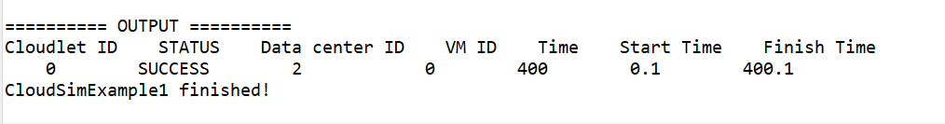
2:  A simple example showing how to create a datacenter with one host and run two cloudlets on it. The cloudlets run in VMs with the same MIPS equirements.  * The cloudlets will take the same time to complete the execution.  2VMs, in same dc, at same host | Starting CloudSimExample2...  Initialising...  Starting CloudSim version 3.0  Datacenter_0 is starting...  Broker is starting...  Entities started.  0.0: Broker: Cloud Resource List received with 1 resource(s)  0.0: Broker: Trying to Create VM #0 in Datacenter_0  0.0: Broker: Trying to Create VM #1 in Datacenter_0  0.1: Broker: VM #0 has been created in Datacenter #2, Host #0  0.1: Broker: VM #1 has been created in Datacenter #2, Host #0  0.1: Broker: Sending cloudlet 0 to VM #0  0.1: Broker: Sending cloudlet 1 to VM #1  1000.1: Broker: Cloudlet 0 received  1000.1: Broker: Cloudlet 1 received  1000.1: Broker: All Cloudlets executed. Finishing...  1000.1: Broker: Destroying VM #0  1000.1: Broker: Destroying VM #1  Broker is shutting down...  Simulation: No more future events  CloudInformationService: Notify all CloudSim entities for shutting down.  Datacenter_0 is shutting down...  Broker is shutting down...  Simulation completed.  Simulation completed.  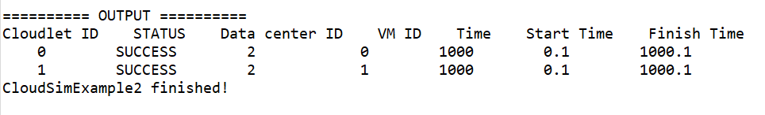
3:  A simple example showing how to create a datacenter with two hosts and run two cloudlets on it. The cloudlets run in * VMs with different MIPS requirements. The cloudlets will take different time to complete the execution depending on the requested VM performance.  2vms on dc0, but both at diff host, cloudlet=2, | Starting CloudSimExample3...  Initialising...  Starting CloudSim version 3.0  Datacenter_0 is starting...  Broker is starting...  Entities started.  0.0: Broker: Cloud Resource List received with 1 resource(s)  0.0: Broker: Trying to Create VM #0 in Datacenter_0  0.0: Broker: Trying to Create VM #1 in Datacenter_0  0.1: Broker: VM #0 has been created in Datacenter #2, Host #0  0.1: Broker: VM #1 has been created in Datacenter #2, Host #1  0.1: Broker: Sending cloudlet 0 to VM #0  0.1: Broker: Sending cloudlet 1 to VM #1  80.1: Broker: Cloudlet 1 received  160.1: Broker: Cloudlet 0 received  160.1: Broker: All Cloudlets executed. Finishing...  160.1: Broker: Destroying VM #0  160.1: Broker: Destroying VM #1  Broker is shutting down...  Simulation: No more future events  CloudInformationService: Notify all CloudSim entities for shutting down.  Datacenter_0 is shutting down...  Broker is shutting down...  Simulation completed.  Simulation completed.  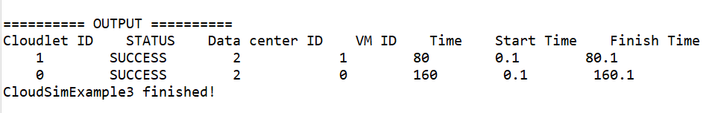
4.  A simple example showing how to create two datacenters with one host each and run two cloudlets on them. | Starting CloudSimExample4...  Initialising...  Starting CloudSim version 3.0  Datacenter_0 is starting...  Datacenter_1 is starting...  Broker is starting...  Entities started.  0.0: Broker: Cloud Resource List received with 2 resource(s)  0.0: Broker: Trying to Create VM #0 in Datacenter_0  0.0: Broker: Trying to Create VM #1 in Datacenter_0  [VmScheduler.vmCreate] Allocation of VM #1 to Host #0 failed by MIPS  0.1: Broker: VM #0 has been created in Datacenter #2, Host #0  0.1: Broker: Creation of VM #1 failed in Datacenter #2  0.1: Broker: Trying to Create VM #1 in Datacenter_1  0.2: Broker: VM #1 has been created in Datacenter #3, Host #0  0.2: Broker: Sending cloudlet 0 to VM #0  0.2: Broker: Sending cloudlet 1 to VM #1  160.2: Broker: Cloudlet 0 received  160.2: Broker: Cloudlet 1 received  160.2: Broker: All Cloudlets executed. Finishing...  160.2: Broker: Destroying VM #0  160.2: Broker: Destroying VM #1  Broker is shutting down...  Simulation: No more future events  CloudInformationService: Notify all CloudSim entities for shutting down.  Datacenter_0 is shutting down...  Datacenter_1 is shutting down...  Broker is shutting down...  Simulation completed.  Simulation completed.  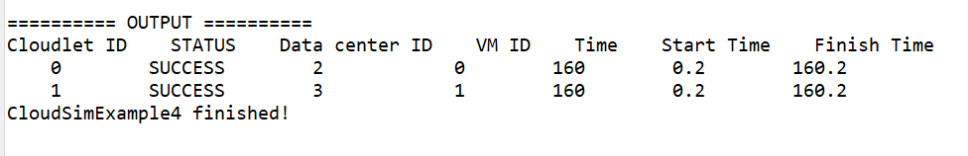
5.  A simple example showing how to create two datacenters with one host each and run cloudlets of two users on them. | Starting CloudSimExample5...  Initialising...  Starting CloudSim version 3.0  Datacenter_0 is starting...  Datacenter_1 is starting...  Broker1 is starting...  Broker2 is starting...  Entities started.  0.0: Broker1: Cloud Resource List received with 2 resource(s)  0.0: Broker2: Cloud Resource List received with 2 resource(s)  0.0: Broker1: Trying to Create VM #0 in Datacenter_0  0.0: Broker2: Trying to Create VM #0 in Datacenter_0  [VmScheduler.vmCreate] Allocation of VM #0 to Host #0 failed by MIPS  0.1: Broker1: VM #0 has been created in Datacenter #2, Host #0  0.1: Broker1: Sending cloudlet 0 to VM #0  0.1: Broker2: Creation of VM #0 failed in Datacenter #2  0.1: Broker2: Trying to Create VM #0 in Datacenter_1  0.2: Broker2: VM #0 has been created in Datacenter #3, Host #0  0.2: Broker2: Sending cloudlet 0 to VM #0  160.1: Broker1: Cloudlet 0 received  160.1: Broker1: All Cloudlets executed. Finishing...  160.1: Broker1: Destroying VM #0  Broker1 is shutting down...  160.2: Broker2: Cloudlet 0 received  160.2: Broker2: All Cloudlets executed. Finishing...  160.2: Broker2: Destroying VM #0  Broker2 is shutting down...  Simulation: No more future events  CloudInformationService: Notify all CloudSim entities for shutting down.  Datacenter_0 is shutting down...  Datacenter_1 is shutting down...  Broker1 is shutting down...  Broker2 is shutting down...  Simulation completed.  Simulation completed.  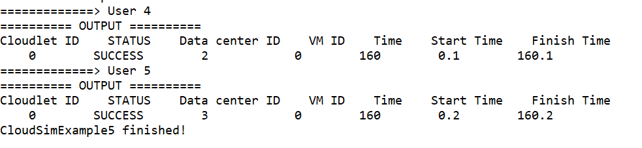
6.  * An example showing how to create scalable simulations. | Starting CloudSimExample6...  Initialising...  Starting CloudSim version 3.0  Datacenter_0 is starting...  Datacenter_1 is starting...  Broker is starting...  Entities started.  0.0: Broker: Cloud Resource List received with 2 resource(s)  0.0: Broker: Trying to Create VM #0 in Datacenter_0  0.0: Broker: Trying to Create VM #1 in Datacenter_0  0.0: Broker: Trying to Create VM #2 in Datacenter_0  0.0: Broker: Trying to Create VM #3 in Datacenter_0  0.0: Broker: Trying to Create VM #4 in Datacenter_0  0.0: Broker: Trying to Create VM #5 in Datacenter_0  0.0: Broker: Trying to Create VM #6 in Datacenter_0  0.0: Broker: Trying to Create VM #7 in Datacenter_0  0.0: Broker: Trying to Create VM #8 in Datacenter_0  0.0: Broker: Trying to Create VM #9 in Datacenter_0  0.0: Broker: Trying to Create VM #10 in Datacenter_0  0.0: Broker: Trying to Create VM #11 in Datacenter_0  0.0: Broker: Trying to Create VM #12 in Datacenter_0  0.0: Broker: Trying to Create VM #13 in Datacenter_0  0.0: Broker: Trying to Create VM #14 in Datacenter_0  0.0: Broker: Trying to Create VM #15 in Datacenter_0  0.0: Broker: Trying to Create VM #16 in Datacenter_0  0.0: Broker: Trying to Create VM #17 in Datacenter_0  0.0: Broker: Trying to Create VM #18 in Datacenter_0  0.0: Broker: Trying to Create VM #19 in Datacenter_0  [VmScheduler.vmCreate] Allocation of VM #6 to Host #0 failed by RAM  [VmScheduler.vmCreate] Allocation of VM #6 to Host #1 failed by MIPS  [VmScheduler.vmCreate] Allocation of VM #7 to Host #0 failed by RAM  [VmScheduler.vmCreate] Allocation of VM #7 to Host #1 failed by MIPS  [VmScheduler.vmCreate] Allocation of VM #8 to Host #0 failed by RAM  [VmScheduler.vmCreate] Allocation of VM #8 to Host #1 failed by MIPS  [VmScheduler.vmCreate] Allocation of VM #9 to Host #0 failed by RAM  [VmScheduler.vmCreate] Allocation of VM #9 to Host #1 failed by MIPS  [VmScheduler.vmCreate] Allocation of VM #10 to Host #0 failed by RAM  [VmScheduler.vmCreate] Allocation of VM #10 to Host #1 failed by MIPS  [VmScheduler.vmCreate] Allocation of VM #11 to Host #0 failed by RAM  [VmScheduler.vmCreate] Allocation of VM #11 to Host #1 failed by MIPS  [VmScheduler.vmCreate] Allocation of VM #12 to Host #0 failed by RAM  [VmScheduler.vmCreate] Allocation of VM #12 to Host #1 failed by MIPS  [VmScheduler.vmCreate] Allocation of VM #13 to Host #0 failed by RAM  [VmScheduler.vmCreate] Allocation of VM #13 to Host #1 failed by MIPS  [VmScheduler.vmCreate] Allocation of VM #14 to Host #0 failed by RAM  [VmScheduler.vmCreate] Allocation of VM #14 to Host #1 failed by MIPS  [VmScheduler.vmCreate] Allocation of VM #15 to Host #0 failed by RAM  [VmScheduler.vmCreate] Allocation of VM #15 to Host #1 failed by MIPS  [VmScheduler.vmCreate] Allocation of VM #16 to Host #0 failed by RAM  [VmScheduler.vmCreate] Allocation of VM #16 to Host #1 failed by MIPS  [VmScheduler.vmCreate] Allocation of VM #17 to Host #0 failed by RAM  [VmScheduler.vmCreate] Allocation of VM #17 to Host #1 failed by MIPS  [VmScheduler.vmCreate] Allocation of VM #18 to Host #0 failed by RAM  [VmScheduler.vmCreate] Allocation of VM #18 to Host #1 failed by MIPS  [VmScheduler.vmCreate] Allocation of VM #19 to Host #0 failed by RAM  [VmScheduler.vmCreate] Allocation of VM #19 to Host #1 failed by MIPS  0.1: Broker: VM #0 has been created in Datacenter #2, Host #0  0.1: Broker: VM #1 has been created in Datacenter #2, Host #0  0.1: Broker: VM #2 has been created in Datacenter #2, Host #0  0.1: Broker: VM #3 has been created in Datacenter #2, Host #1  0.1: Broker: VM #4 has been created in Datacenter #2, Host #0  0.1: Broker: VM #5 has been created in Datacenter #2, Host #1  0.1: Broker: Creation of VM #6 failed in Datacenter #2  0.1: Broker: Creation of VM #7 failed in Datacenter #2  0.1: Broker: Creation of VM #8 failed in Datacenter #2  0.1: Broker: Creation of VM #9 failed in Datacenter #2  0.1: Broker: Creation of VM #10 failed in Datacenter #2  0.1: Broker: Creation of VM #11 failed in Datacenter #2  0.1: Broker: Creation of VM #12 failed in Datacenter #2  0.1: Broker: Creation of VM #13 failed in Datacenter #2  0.1: Broker: Creation of VM #14 failed in Datacenter #2  0.1: Broker: Creation of VM #15 failed in Datacenter #2  0.1: Broker: Creation of VM #16 failed in Datacenter #2  0.1: Broker: Creation of VM #17 failed in Datacenter #2  0.1: Broker: Creation of VM #18 failed in Datacenter #2  0.1: Broker: Creation of VM #19 failed in Datacenter #2  0.1: Broker: Trying to Create VM #6 in Datacenter_1  0.1: Broker: Trying to Create VM #7 in Datacenter_1  0.1: Broker: Trying to Create VM #8 in Datacenter_1  0.1: Broker: Trying to Create VM #9 in Datacenter_1  0.1: Broker: Trying to Create VM #10 in Datacenter_1  0.1: Broker: Trying to Create VM #11 in Datacenter_1  0.1: Broker: Trying to Create VM #12 in Datacenter_1  0.1: Broker: Trying to Create VM #13 in Datacenter_1  0.1: Broker: Trying to Create VM #14 in Datacenter_1  0.1: Broker: Trying to Create VM #15 in Datacenter_1  0.1: Broker: Trying to Create VM #16 in Datacenter_1  0.1: Broker: Trying to Create VM #17 in Datacenter_1  0.1: Broker: Trying to Create VM #18 in Datacenter_1  0.1: Broker: Trying to Create VM #19 in Datacenter_1  [VmScheduler.vmCreate] Allocation of VM #12 to Host #0 failed by RAM  [VmScheduler.vmCreate] Allocation of VM #12 to Host #1 failed by MIPS  [VmScheduler.vmCreate] Allocation of VM #13 to Host #0 failed by RAM  [VmScheduler.vmCreate] Allocation of VM #13 to Host #1 failed by MIPS  [VmScheduler.vmCreate] Allocation of VM #14 to Host #0 failed by RAM  [VmScheduler.vmCreate] Allocation of VM #14 to Host #1 failed by MIPS  [VmScheduler.vmCreate] Allocation of VM #15 to Host #0 failed by RAM  [VmScheduler.vmCreate] Allocation of VM #15 to Host #1 failed by MIPS  [VmScheduler.vmCreate] Allocation of VM #16 to Host #0 failed by RAM  [VmScheduler.vmCreate] Allocation of VM #16 to Host #1 failed by MIPS  [VmScheduler.vmCreate] Allocation of VM #17 to Host #0 failed by RAM  [VmScheduler.vmCreate] Allocation of VM #17 to Host #1 failed by MIPS  [VmScheduler.vmCreate] Allocation of VM #18 to Host #0 failed by RAM  [VmScheduler.vmCreate] Allocation of VM #18 to Host #1 failed by MIPS  [VmScheduler.vmCreate] Allocation of VM #19 to Host #0 failed by RAM  [VmScheduler.vmCreate] Allocation of VM #19 to Host #1 failed by MIPS  0.2: Broker: VM #6 has been created in Datacenter #3, Host #0  0.2: Broker: VM #7 has been created in Datacenter #3, Host #0  0.2: Broker: VM #8 has been created in Datacenter #3, Host #0  0.2: Broker: VM #9 has been created in Datacenter #3, Host #1  0.2: Broker: VM #10 has been created in Datacenter #3, Host #0  0.2: Broker: VM #11 has been created in Datacenter #3, Host #1  0.2: Broker: Creation of VM #12 failed in Datacenter #3  0.2: Broker: Creation of VM #13 failed in Datacenter #3  0.2: Broker: Creation of VM #14 failed in Datacenter #3  0.2: Broker: Creation of VM #15 failed in Datacenter #3  0.2: Broker: Creation of VM #16 failed in Datacenter #3  0.2: Broker: Creation of VM #17 failed in Datacenter #3  0.2: Broker: Creation of VM #18 failed in Datacenter #3  0.2: Broker: Creation of VM #19 failed in Datacenter #3  0.2: Broker: Sending cloudlet 0 to VM #0  0.2: Broker: Sending cloudlet 1 to VM #1  0.2: Broker: Sending cloudlet 2 to VM #2  0.2: Broker: Sending cloudlet 3 to VM #3  0.2: Broker: Sending cloudlet 4 to VM #4  0.2: Broker: Sending cloudlet 5 to VM #5  0.2: Broker: Sending cloudlet 6 to VM #6  0.2: Broker: Sending cloudlet 7 to VM #7  0.2: Broker: Sending cloudlet 8 to VM #8  0.2: Broker: Sending cloudlet 9 to VM #9  0.2: Broker: Sending cloudlet 10 to VM #10  0.2: Broker: Sending cloudlet 11 to VM #11  0.2: Broker: Sending cloudlet 12 to VM #0  0.2: Broker: Sending cloudlet 13 to VM #1  0.2: Broker: Sending cloudlet 14 to VM #2  0.2: Broker: Sending cloudlet 15 to VM #3  0.2: Broker: Sending cloudlet 16 to VM #4  0.2: Broker: Sending cloudlet 17 to VM #5  0.2: Broker: Sending cloudlet 18 to VM #6  0.2: Broker: Sending cloudlet 19 to VM #7  0.2: Broker: Sending cloudlet 20 to VM #8  0.2: Broker: Sending cloudlet 21 to VM #9  0.2: Broker: Sending cloudlet 22 to VM #10  0.2: Broker: Sending cloudlet 23 to VM #11  0.2: Broker: Sending cloudlet 24 to VM #0  0.2: Broker: Sending cloudlet 25 to VM #1  0.2: Broker: Sending cloudlet 26 to VM #2  0.2: Broker: Sending cloudlet 27 to VM #3  0.2: Broker: Sending cloudlet 28 to VM #4  0.2: Broker: Sending cloudlet 29 to VM #5  0.2: Broker: Sending cloudlet 30 to VM #6  0.2: Broker: Sending cloudlet 31 to VM #7  0.2: Broker: Sending cloudlet 32 to VM #8  0.2: Broker: Sending cloudlet 33 to VM #9  0.2: Broker: Sending cloudlet 34 to VM #10  0.2: Broker: Sending cloudlet 35 to VM #11  0.2: Broker: Sending cloudlet 36 to VM #0  0.2: Broker: Sending cloudlet 37 to VM #1  0.2: Broker: Sending cloudlet 38 to VM #2  0.2: Broker: Sending cloudlet 39 to VM #3  3.1980000000000004: Broker: Cloudlet 4 received  3.1980000000000004: Broker: Cloudlet 16 received  3.1980000000000004: Broker: Cloudlet 28 received  3.1980000000000004: Broker: Cloudlet 5 received  3.1980000000000004: Broker: Cloudlet 17 received  3.1980000000000004: Broker: Cloudlet 29 received  3.1980000000000004: Broker: Cloudlet 6 received  3.1980000000000004: Broker: Cloudlet 18 received  3.1980000000000004: Broker: Cloudlet 30 received  3.1980000000000004: Broker: Cloudlet 7 received  3.1980000000000004: Broker: Cloudlet 19 received  3.1980000000000004: Broker: Cloudlet 31 received  3.1980000000000004: Broker: Cloudlet 8 received  3.1980000000000004: Broker: Cloudlet 20 received  3.1980000000000004: Broker: Cloudlet 32 received  3.1980000000000004: Broker: Cloudlet 10 received  3.1980000000000004: Broker: Cloudlet 22 received  3.1980000000000004: Broker: Cloudlet 34 received  3.1980000000000004: Broker: Cloudlet 9 received  3.1980000000000004: Broker: Cloudlet 21 received  3.1980000000000004: Broker: Cloudlet 33 received  3.1980000000000004: Broker: Cloudlet 11 received  3.1980000000000004: Broker: Cloudlet 23 received  3.1980000000000004: Broker: Cloudlet 35 received  4.198: Broker: Cloudlet 0 received  4.198: Broker: Cloudlet 12 received  4.198: Broker: Cloudlet 24 received  4.198: Broker: Cloudlet 36 received  4.198: Broker: Cloudlet 1 received  4.198: Broker: Cloudlet 13 received  4.198: Broker: Cloudlet 25 received  4.198: Broker: Cloudlet 37 received  4.198: Broker: Cloudlet 2 received  4.198: Broker: Cloudlet 14 received  4.198: Broker: Cloudlet 26 received  4.198: Broker: Cloudlet 38 received  4.198: Broker: Cloudlet 3 received  4.198: Broker: Cloudlet 15 received  4.198: Broker: Cloudlet 27 received  4.198: Broker: Cloudlet 39 received  4.198: Broker: All Cloudlets executed. Finishing...  4.198: Broker: Destroying VM #0  4.198: Broker: Destroying VM #1  4.198: Broker: Destroying VM #2  4.198: Broker: Destroying VM #3  4.198: Broker: Destroying VM #4  4.198: Broker: Destroying VM #5  4.198: Broker: Destroying VM #6  4.198: Broker: Destroying VM #7  4.198: Broker: Destroying VM #8  4.198: Broker: Destroying VM #9  4.198: Broker: Destroying VM #10  4.198: Broker: Destroying VM #11  Broker is shutting down...  Simulation: No more future events  CloudInformationService: Notify all CloudSim entities for shutting down.  Datacenter_0 is shutting down...  Datacenter_1 is shutting down...  Broker is shutting down...  Simulation completed.  Simulation completed.  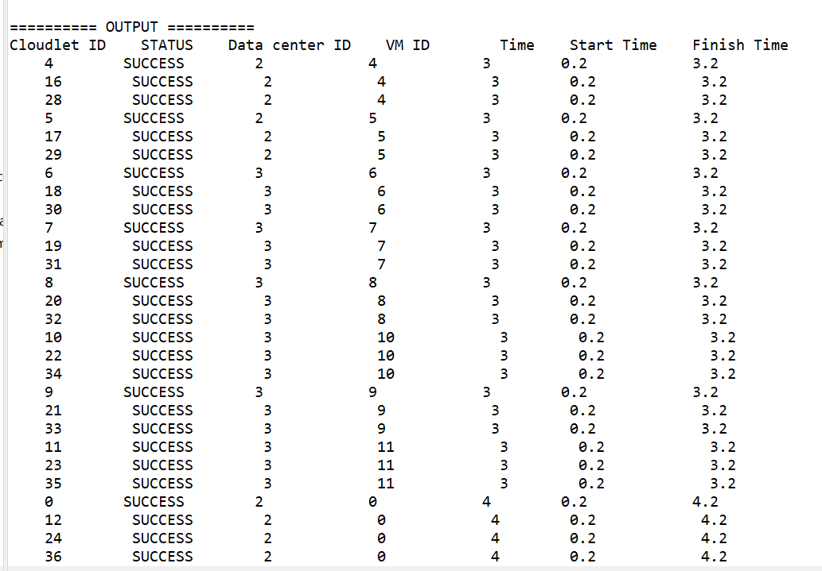
7. An example showing how to pause and resume the simulation,  * and create simulation entities (a DatacenterBroker in this example)  * dynamically. | Starting CloudSimExample7...  Initialising...  Starting CloudSim version 3.0  Datacenter_0 is starting...  Datacenter_1 is starting...  Broker_0 is starting...  Entities started.  0.0: Broker_0: Cloud Resource List received with 2 resource(s)  0.0: Broker_0: Trying to Create VM #0 in Datacenter_0  0.0: Broker_0: Trying to Create VM #1 in Datacenter_0  0.0: Broker_0: Trying to Create VM #2 in Datacenter_0  0.0: Broker_0: Trying to Create VM #3 in Datacenter_0  0.0: Broker_0: Trying to Create VM #4 in Datacenter_0  0.1: Broker_0: VM #0 has been created in Datacenter #2, Host #0  0.1: Broker_0: VM #1 has been created in Datacenter #2, Host #0  0.1: Broker_0: VM #2 has been created in Datacenter #2, Host #0  0.1: Broker_0: VM #3 has been created in Datacenter #2, Host #1  0.1: Broker_0: VM #4 has been created in Datacenter #2, Host #0  0.1: Broker_0: Sending cloudlet 0 to VM #0  0.1: Broker_0: Sending cloudlet 1 to VM #1  0.1: Broker_0: Sending cloudlet 2 to VM #2  0.1: Broker_0: Sending cloudlet 3 to VM #3  0.1: Broker_0: Sending cloudlet 4 to VM #4  0.1: Broker_0: Sending cloudlet 5 to VM #0  0.1: Broker_0: Sending cloudlet 6 to VM #1  0.1: Broker_0: Sending cloudlet 7 to VM #2  0.1: Broker_0: Sending cloudlet 8 to VM #3  0.1: Broker_0: Sending cloudlet 9 to VM #4  200.0: The simulation is paused for 5 sec  Adding: Broker_1  Broker_1 is starting...  200.0: Broker_1: Cloud Resource List received with 2 resource(s)  200.0: Broker_1: Trying to Create VM #100 in Datacenter_0  200.0: Broker_1: Trying to Create VM #101 in Datacenter_0  200.0: Broker_1: Trying to Create VM #102 in Datacenter_0  200.0: Broker_1: Trying to Create VM #103 in Datacenter_0  200.0: Broker_1: Trying to Create VM #104 in Datacenter_0  200.1: Broker_1: VM #100 has been created in Datacenter #2, Host #1  200.1: Broker_1: VM #101 has been created in Datacenter #2, Host #0  200.1: Broker_1: VM #102 has been created in Datacenter #2, Host #1  200.1: Broker_1: VM #103 has been created in Datacenter #2, Host #0  200.1: Broker_1: VM #104 has been created in Datacenter #2, Host #1  200.1: Broker_1: Sending cloudlet 100 to VM #100  200.1: Broker_1: Sending cloudlet 101 to VM #101  200.1: Broker_1: Sending cloudlet 102 to VM #102  200.1: Broker_1: Sending cloudlet 103 to VM #103  200.1: Broker_1: Sending cloudlet 104 to VM #104  200.1: Broker_1: Sending cloudlet 105 to VM #100  200.1: Broker_1: Sending cloudlet 106 to VM #101  200.1: Broker_1: Sending cloudlet 107 to VM #102  200.1: Broker_1: Sending cloudlet 108 to VM #103  200.1: Broker_1: Sending cloudlet 109 to VM #104  320.096: Broker_0: Cloudlet 0 received  320.096: Broker_0: Cloudlet 5 received  320.096: Broker_0: Cloudlet 1 received  320.096: Broker_0: Cloudlet 6 received  320.096: Broker_0: Cloudlet 2 received  320.096: Broker_0: Cloudlet 7 received  320.096: Broker_0: Cloudlet 4 received  320.096: Broker_0: Cloudlet 9 received  320.096: Broker_0: Cloudlet 3 received  320.096: Broker_0: Cloudlet 8 received  320.096: Broker_0: All Cloudlets executed. Finishing...  320.096: Broker_0: Destroying VM #0  320.096: Broker_0: Destroying VM #1  320.096: Broker_0: Destroying VM #2  320.096: Broker_0: Destroying VM #3  320.096: Broker_0: Destroying VM #4  Broker_0 is shutting down...  519.996: Broker_1: Cloudlet 101 received  519.996: Broker_1: Cloudlet 106 received  519.996: Broker_1: Cloudlet 103 received  519.996: Broker_1: Cloudlet 108 received  519.996: Broker_1: Cloudlet 100 received  519.996: Broker_1: Cloudlet 105 received  519.996: Broker_1: Cloudlet 102 received  519.996: Broker_1: Cloudlet 107 received  519.996: Broker_1: Cloudlet 104 received  519.996: Broker_1: Cloudlet 109 received  519.996: Broker_1: All Cloudlets executed. Finishing...  519.996: Broker_1: Destroying VM #100  519.996: Broker_1: Destroying VM #101  519.996: Broker_1: Destroying VM #102  519.996: Broker_1: Destroying VM #103  519.996: Broker_1: Destroying VM #104  Broker_1 is shutting down...  Simulation: No more future events  CloudInformationService: Notify all CloudSim entities for shutting down.  Datacenter_0 is shutting down...  Datacenter_1 is shutting down...  Broker_0 is shutting down...  Broker_1 is shutting down...  Simulation completed.  Simulation completed.  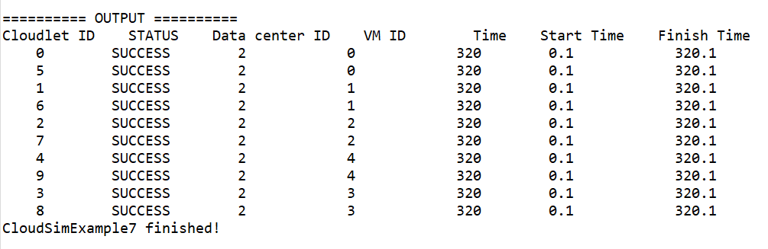
8. An example showing how to create simulation entities  * (a DatacenterBroker in this example) in run-time using  * a globar manager entity (GlobalBroker).  */ | Starting CloudSimExample8...  Initialising...  Starting CloudSim version 3.0  GlobalBroker is starting...  Datacenter_0 is starting...  Datacenter_1 is starting...  Broker_0 is starting...  Entities started.  0.0: Broker_0: Cloud Resource List received with 2 resource(s)  0.0: Broker_0: Trying to Create VM #0 in Datacenter_0  0.0: Broker_0: Trying to Create VM #1 in Datacenter_0  0.0: Broker_0: Trying to Create VM #2 in Datacenter_0  0.0: Broker_0: Trying to Create VM #3 in Datacenter_0  0.0: Broker_0: Trying to Create VM #4 in Datacenter_0  0.1: Broker_0: VM #0 has been created in Datacenter #3, Host #0  0.1: Broker_0: VM #1 has been created in Datacenter #3, Host #0  0.1: Broker_0: VM #2 has been created in Datacenter #3, Host #0  0.1: Broker_0: VM #3 has been created in Datacenter #3, Host #1  0.1: Broker_0: VM #4 has been created in Datacenter #3, Host #0  0.1: Broker_0: Sending cloudlet 0 to VM #0  0.1: Broker_0: Sending cloudlet 1 to VM #1  0.1: Broker_0: Sending cloudlet 2 to VM #2  0.1: Broker_0: Sending cloudlet 3 to VM #3  0.1: Broker_0: Sending cloudlet 4 to VM #4  0.1: Broker_0: Sending cloudlet 5 to VM #0  0.1: Broker_0: Sending cloudlet 6 to VM #1  0.1: Broker_0: Sending cloudlet 7 to VM #2  0.1: Broker_0: Sending cloudlet 8 to VM #3  0.1: Broker_0: Sending cloudlet 9 to VM #4  Adding: GlobalBroker_  GlobalBroker_ is starting...  200.0: GlobalBroker_: Cloud Resource List received with 2 resource(s)  200.0: GlobalBroker_: Trying to Create VM #100 in Datacenter_0  200.0: GlobalBroker_: Trying to Create VM #101 in Datacenter_0  200.0: GlobalBroker_: Trying to Create VM #102 in Datacenter_0  200.0: GlobalBroker_: Trying to Create VM #103 in Datacenter_0  200.0: GlobalBroker_: Trying to Create VM #104 in Datacenter_0  200.1: GlobalBroker_: VM #100 has been created in Datacenter #3, Host #1  200.1: GlobalBroker_: VM #101 has been created in Datacenter #3, Host #0  200.1: GlobalBroker_: VM #102 has been created in Datacenter #3, Host #1  200.1: GlobalBroker_: VM #103 has been created in Datacenter #3, Host #0  200.1: GlobalBroker_: VM #104 has been created in Datacenter #3, Host #1  200.1: GlobalBroker_: Sending cloudlet 100 to VM #100  200.1: GlobalBroker_: Sending cloudlet 101 to VM #101  200.1: GlobalBroker_: Sending cloudlet 102 to VM #102  200.1: GlobalBroker_: Sending cloudlet 103 to VM #103  200.1: GlobalBroker_: Sending cloudlet 104 to VM #104  200.1: GlobalBroker_: Sending cloudlet 105 to VM #100  200.1: GlobalBroker_: Sending cloudlet 106 to VM #101  200.1: GlobalBroker_: Sending cloudlet 107 to VM #102  200.1: GlobalBroker_: Sending cloudlet 108 to VM #103  200.1: GlobalBroker_: Sending cloudlet 109 to VM #104  320.1: Broker_0: Cloudlet 0 received  320.1: Broker_0: Cloudlet 5 received  320.1: Broker_0: Cloudlet 1 received  320.1: Broker_0: Cloudlet 6 received  320.1: Broker_0: Cloudlet 2 received  320.1: Broker_0: Cloudlet 7 received  320.1: Broker_0: Cloudlet 4 received  320.1: Broker_0: Cloudlet 9 received  320.1: Broker_0: Cloudlet 3 received  320.1: Broker_0: Cloudlet 8 received  320.1: Broker_0: All Cloudlets executed. Finishing...  320.1: Broker_0: Destroying VM #0  320.1: Broker_0: Destroying VM #1  320.1: Broker_0: Destroying VM #2  320.1: Broker_0: Destroying VM #3  320.1: Broker_0: Destroying VM #4  Broker_0 is shutting down...  520.1: GlobalBroker_: Cloudlet 101 received  520.1: GlobalBroker_: Cloudlet 106 received  520.1: GlobalBroker_: Cloudlet 103 received  520.1: GlobalBroker_: Cloudlet 108 received  520.1: GlobalBroker_: Cloudlet 100 received  520.1: GlobalBroker_: Cloudlet 105 received  520.1: GlobalBroker_: Cloudlet 102 received  520.1: GlobalBroker_: Cloudlet 107 received  520.1: GlobalBroker_: Cloudlet 104 received  520.1: GlobalBroker_: Cloudlet 109 received  520.1: GlobalBroker_: All Cloudlets executed. Finishing...  520.1: GlobalBroker_: Destroying VM #100  520.1: GlobalBroker_: Destroying VM #101  520.1: GlobalBroker_: Destroying VM #102  520.1: GlobalBroker_: Destroying VM #103  520.1: GlobalBroker_: Destroying VM #104  GlobalBroker_ is shutting down...  Simulation: No more future events  CloudInformationService: Notify all CloudSim entities for shutting down.  Datacenter_0 is shutting down...  Datacenter_1 is shutting down...  Broker_0 is shutting down...  GlobalBroker_ is shutting down...  Simulation completed.  Simulation completed.  